Personal Case Study Submitted in Partial Fulfillment of Digital Strategy and Innovation April 2019

The Dental Divide – Can Health Data Mend an Ailing Industry?

Twenty-five years ago, treatment for major dental procedures was covered by major medical insurance. Before the linkages between untreated dental disease and other maladies such as heart disease and diabetes were recognized, an industry-wide move to reduce the risks/costs of medical insurance eliminated coverage for dental care and mental health care under medical plans. The idea was these other types of care would be covered by dental and mental health insurance policies. The costs of such policies proved financially unfeasible without the broader participation of medical services.

Today, to control risk/costs, dental insurance tends to either exclude major procedures such as periodontal care or limits total annual benefits to ~$1000, which is not enough to cover the cost of treatment. 114 million Americans don’t have dental insurance, including 46.3 million people aged 65 according to the National Association of Dental Plans. Using data from the 2014 National Health Interview Survey, Health Affairs Journal analyzed financial barriers to a wide range of health care services. They found that “irrespective of age, income level, and type of insurance, more people reported financial barriers to receiving dental care, compared to any other type of health care.”

Beyond the moral and ethical nature of the question, is untreated dental disease such a big deal? Yes. Untreated periodontitis (i.e. gum or periodontal disease) is a chronic inflammatory disease that exacerbates, and is exacerbated in turn, by other chronic inflammatory diseases such as heart disease, diabetes, and, potentially, Alzheimer’s. “People with chronic conditions are the most frequent users of health care in the U.S. They account for

- 81% of hospital admissions,
- 91% of all prescriptions filled,
- and 76% of all physician visits.

Chronic diseases also account for most of health care spending. In the U.S., total spending on public and private health care amounted to approximately $2 trillion during 2005. Of that amount, more than 75% went toward treatment of chronic disease. In publicly funded health programs, spending on chronic disease represents an even greater proportion of total spending: more than 99% in Medicare and 83% in Medicaid. When a diabetic patient with periodontal disease forgoes treatment because they can’t afford it, everyone pays.

Innovations in how we collect, analyze and deploy health data may narrow the dental care affordability divide. There are significant challenges to accessing this data and turning it into actionable information, chief among them are the legality of access and the structure of the data.

Personal health information privacy is strictly regulated by the Health Insurance Privacy and Portability Act of 1996 and other regulations. However, these regulations allow individuals to voluntarily agree in writing to share their data with others. For many of the same intrinsic, extrinsic, and community motivations that induce people to voluntarily participate in crowdsourcing exercises, people are agreeing in large numbers to allow their data to be accessed, evaluated and shared.

Health data is scattered in legacy paper files and throughout digital sources like electronic health records (EHR), prescription databases, wearables, and genetic databases such as 23andMe. Medical and dental data use different codes and different coding taxonomies; they weren’t designed to talk to each other. Many data firms are starting from scratch. Apples new iPhone accepts data from devices that measure blood sugar, heart rate, and fall detection. Data is imported directly into Apple’s new Health Record Service which is built into its most recent iOS. This lets patients store their personal medical data on their phones and provides new users for its Health Kit platform. “Consumers who choose to make their encrypted data available to third-party apps, will share that information with developers working on tools like medication tracking, disease management, nutrition planning and medical research.” ,

Data organizations who can turn this mass of data into useable bits of information for on demand use will reap rich rewards. Such information would be a significant value creator for the individual provider as well. First consider that dentists and physicians make treatment decisions based on their personal education and experience. Unlike physicians, 51% of dentists work in one-dentist settings limiting fruitful real-time exchange with other providers.

Using the perennial dental bogeyman of a dry socket as an example, Joseph Finkelstein, MD, PhD, Associate Professor of Dental Bioinformatics at Columbia University and Co-Director for the Center for Bioinformatics and Data Analytics in Oral Health explains, “the current EHR does not reliably identify all dry socket cases, making it hard to locate all people who suffer this condition. Using a strategy called deep phenotyping, researchers at Columbia are developing algorithms to determine the signature traits of dry socket, then identify patients who share those traits.” A dentist, having this information, could treat patients differently based on those traits. On the level of the individual dentist, having information to reduce the occurrence of dry sockets allows him or her to create value by directly improving patient well-being and satisfaction and captures value by reducing the cost of un-reimbursed follow-up appointments and supplementary treatment.

Insurance:

Who pays is the perennial health care problem. One of the most hopeful paths for mending the ailing dental industry is through innovations in insurance. Tech giants like Apple and Google are leveraging IoT devices and wearables to collect behavioral data on their customers. Florian Graillot, writing in Medium.com, argues “this might be a key advantage for these companies especially to feed algorithms — that become more relevant with higher amount of data — and a first step before launching health insurance products.”

All this data is leading to better predictive models. Insurers are trying to gain market share by leveraging improved algorithms. Like waves going up the beach, each innovation in the insurance game gains a bit more ground.

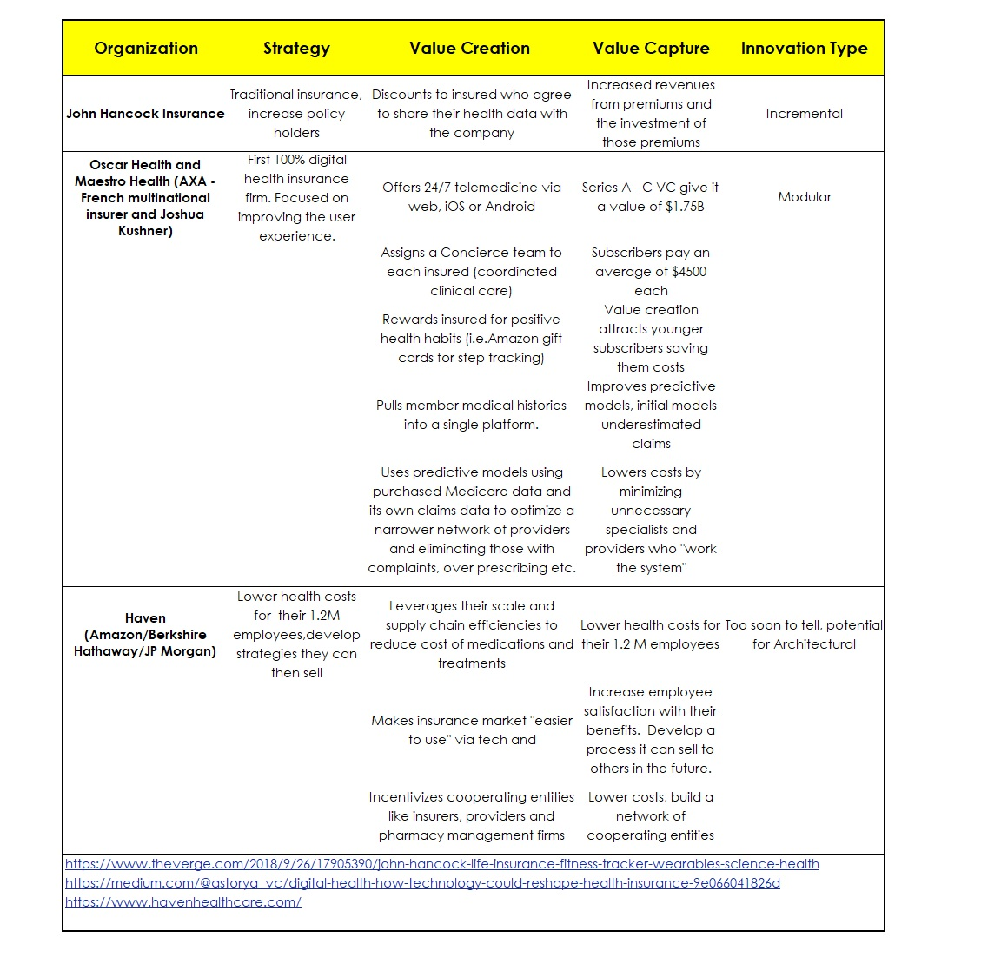
Figure 1 Digitally Driven Innovations In Health Insurance
Google sister-company Verily has taken the next step. Its business model uses more and better data to predict future health costs for a group of people. They then risk share with partners like insurance companies or employers and share in savings – integrating themselves into the insurance market without necessarily becoming an insurance company. Including coverage for medically necessary major dental treatment as part of the medical policies offered will enable the Verily partners achieve significantly greater cost savings than just the incremental innovations of “better predictive algorithms” approach used by competitors. This horizontal integration is way outside the health insurance norm, risk sharing and potential for increased cost savings should help to push the new strategy into the marketplace. The dental component should also increase pull-through demand by policy holders given the absence of coverage options for these procedures through any other means. The combination of a new avenue of cost savings, better data-driven predictive abilities, risk sharing with payors, and demand by consumers constitutes an architectural innovation in my view, one with which it should be hard for traditional insurance companies to compete. This architectural innovation has the potential to result in classic ‘hockey stick’ sales increases and industry disruption. Moreover, it has the potential to result in better health for its customers and mend an ailing industry.

Conclusion:

It is perhaps not surprising to find that Tim Cook of Apple identified that health data is the business sweet spot in the whole health care cycle because “who pays” is not an issue, as we’ve seen with Verily.

“When you look at most of the [current health care] solutions, whether it’s devices, or things coming up out of Big Pharma, first and foremost, they are done to get the reimbursement [from an insurance provider]. Not thinking about what helps the patient. So if you don’t care about reimbursement, which we have the privilege of doing, that [the health care market] may even make the smartphone market look small.”

Tim Cook, CEO, Apple Inc.

Endnotes:

The decision to include, or exclude, types of procedures from a given insurance policy is decided by the insurer, not dictated by the regulation except in cases such as the Affordable Care Act that directed all policies sold on the exchanges would include certain benefits such as children’s dental coverage.
Lawyers are definitely getting their slice of the pie
A list of the medical organization who accept Apple medical records may be found at https://support.apple.com/en-us/HT208647
Is there a wearable for dental disease? Not exactly, but bacterial loads and/or the genetic predisposition for periodontitis can be determined with a “spit test” such as OralDNA which has been developed but not commercialized. However, despite literally dozens of studies and meta-analyses as reviewed by the American Dental Association, as of August 2018, the FDA has not approved any salivary diagnostic tests for evaluating risk of periodontal disease or dental caries, or head and neck cancer.
https://www.buzzfeednews.com/article/johnstanton/americans-going-to-dentists-in-molar-city-mexico
https://www.healthaffairs.org/doi/full/10.1377/hlthaff.2016.0800 ,Vujicic Marko; Buchmueller, Thomas; and Klein, Rachel.
https://en.wikipedia.org/wiki/Periodontal_disease See reference for individual citations for different diseases.
https://www.fightchronicdisease.org/sites/default/files/docs/GrowingCrisisofChronicDiseaseintheUSfactsheet_81009.pdf
https://www.cnbc.com/2018/06/04/apple-is-giving-medical-researchers-and-app-developers-new-ways-to-prevent-diseases.html Salivary testing for periodontal disease diagnosis and treatment. Nabors, TW, McGlennen, RC, Thompson D.
. https://www.ada.org/en/publications/ada-news/2018-archive/october/hpi-fewer-dentists-are-practicing-solo
https://www.dental.columbia.edu/dentistrys-revolution-0
https://medium.com/@astorya_vc/digital-health-how-technology-could-reshape-health-insurance-9e066041826d Graillot, Florian.
https://techcrunch.com/2019/01/29/apple-partners-with-aetna-to-launch-health-app-leveraging-apple-watch-data/

